Aerodynamic Conversions
C_{A}
C_{D}
C_{N}
C_{L}
α
α
α
C_{Z}
C_{X}
α

Converting C_{L}, C_{D} to C_{N}, C_{A}

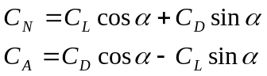

Converting C_{N}, C_{A} to C_{L}, C_{D}

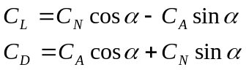

Converting C_{N}, C_{A} / C_{L}, C_{D} to C_{X}, C_{Z}

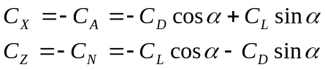

Converting C_{X}, C_{Z} to C_{L}, C_{D}

